1)Calculate the standard deviation by hand (show work) for the following test scores.
80, 86, 88, 92, 99
2) Which of the following data sets has a greater standard
deviation? Explain how you would know the answer to this question without actually calculating the standard deviation in each case.
Set A: 50, 60, 80, 90 Set B: 5, 6, 8, 9
3) A statistics class at college A has 100 students. There are 50 male students in the class and 50 female students in the class.
A statistics class at college B also has 100 students. All the students in this class are female.
Consider the following data sets:
1)The heights of the students in the Statistics class at College A 2) The heights of the students in the Statistics class at College B.
Which data set will likely have a greater standard deviation? Explain.
#2
Two sample problems with solutions:
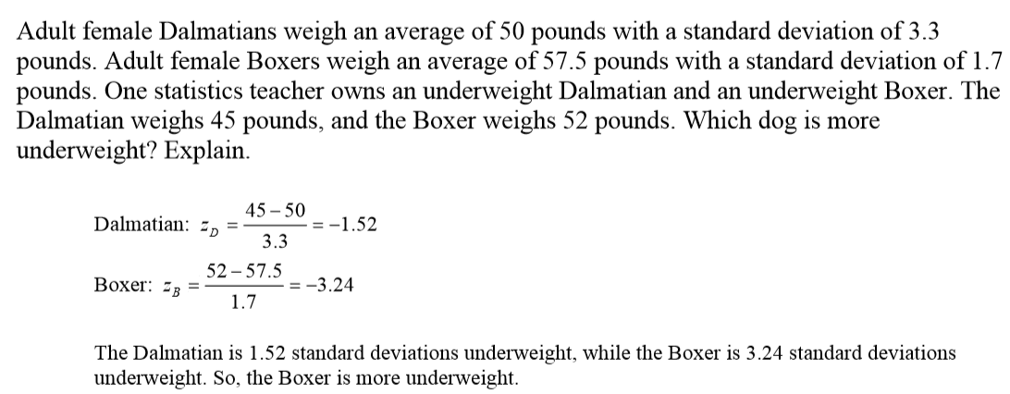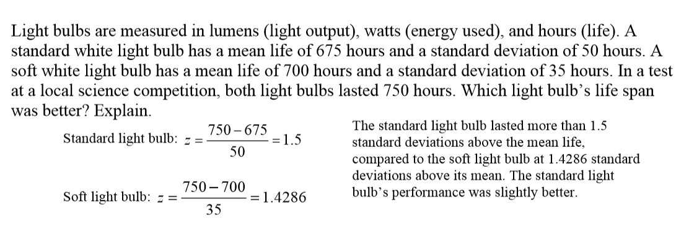
Now answer this question: 4)
